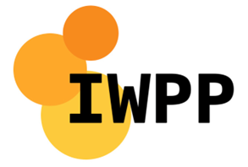

Self Declaration Cum Undertaking Certificate

Certificate Number | IN4136 |  | Date of Issue | 22/03/2025
Invoice Number | 112581 |  | II. Details of Importer
I. Details of Exporter  Independent Waste Paper Producers Ltd  The Stables, Paradise Wharf  Ducie Street  Manchester  M1 2JN  United Kingdom |  |  | VATSALYA PAPER INDUSTRIES, LLP BLOCK NO.1145/A, PLOT NO. 17,18, 142/P/1,1142/P/2, SURVAY NO. 860, MANDVI ROAD, TADKESHWAR, SURAT, GUJARATINDIA – 394170  IEC#: AAOFV9381K  GST No.#: 24AAOFV9381K1ZC  PAN No.: AAOFV9381K

III. Details of Import
Sr. No. | Description of Goods | Quantity
1 | WASTE PAPER-FIBRE CORES | 21.940 MT

IV. Container Numbers
Sr. No. | Container Number | Quantity |  | Sr. No. | Container Number | Quantity
1 | TIIU5871745 | 21.940 MT

After due inspection I/We hereby certify that
- The consignment is actually waste paper as per the internationally acceptable parameters for such material.
- There is no putrefiable organic matter in this consignment
- The approximate content of non-paper material is not more than 5%
- No municipal solid waste or bio-medical waste or Hazardous waste is part of this consignment.

I / We hereby declare that the particulars and statements made in this certificate are true and correct and nothing has

Name of Certify Agency: Independent Waste Paper Producers Ltd

Signature : Official Seal

Date :

